EasyChair instructions for Authors
The submission and review of papers for PECERA 2019 will be managed through an online conference paper management system called EasyChair. This system gives you, the author, complete control over your submission. You can upload your abstract and check on the review status of your submission. The Committee will review all abstracts and notify the results to authors. This guide is intended to support authors during the submission process. It has two parts:
- Setting up an account
- Abstract submission
While the procedure is quite simple, and we do not anticipate users running into trouble, we are happy to help if you encounter problems. In the event that you do need help, please contact pecera2019tw@gmail.com

Set up an account as an Author
First, you will need to set up an account (username and password) as an author. Go to Create an EasyChair Account. You will then be automatically directed to the page shown in Figure 1.

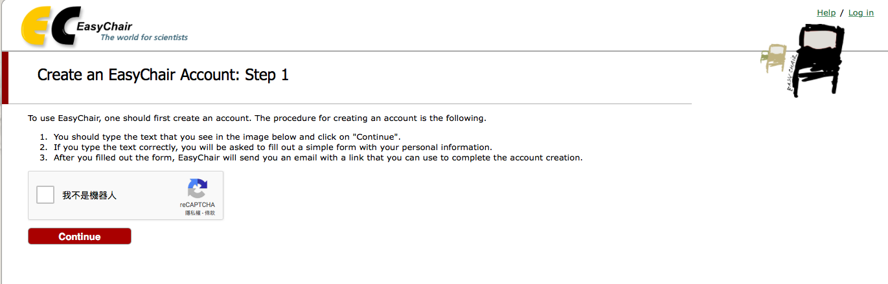
Figure 1: Enter information to sign up

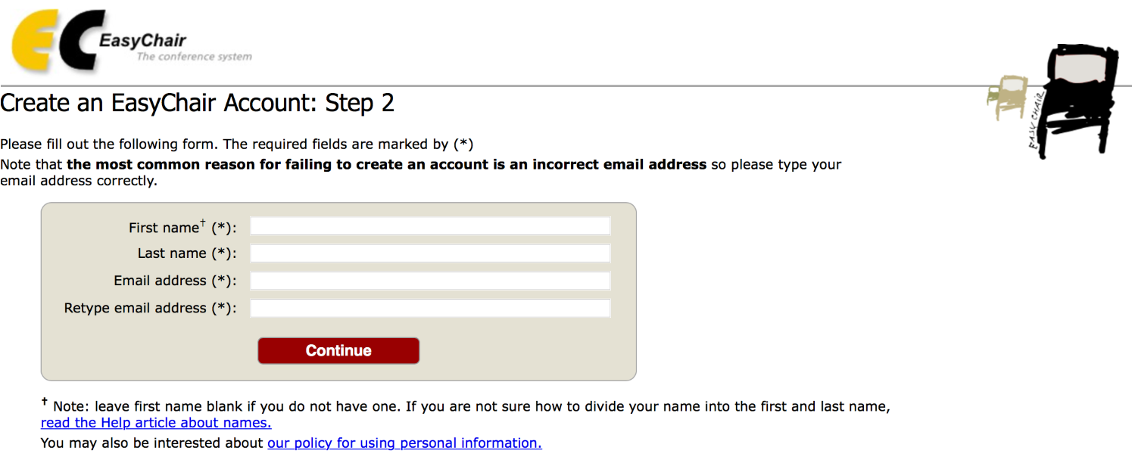
Then, follow the on-screen instructions and complete the form (as shown in Figure 2), and click on “Continue.”
Figure 2: Fill in the form.

After registering, you will receive an email like the one in Figure 3. Use the link provided in the email to continue the account registration process.

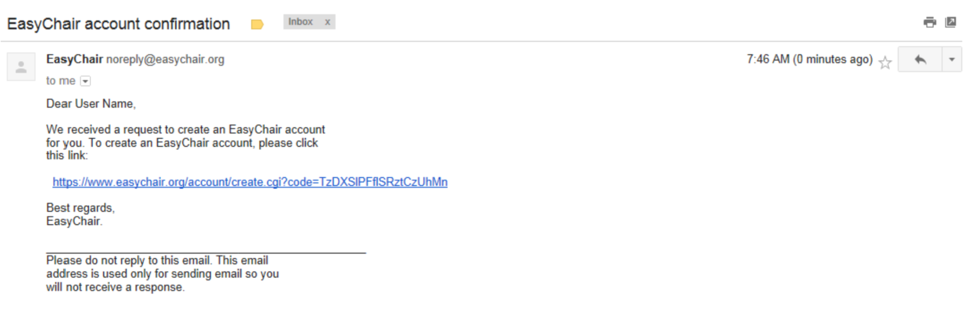Figure 3: Log in email.

Fill out all the required information (as shown in Figure 4) and click the “Create my account” button to finalize the account registration process.

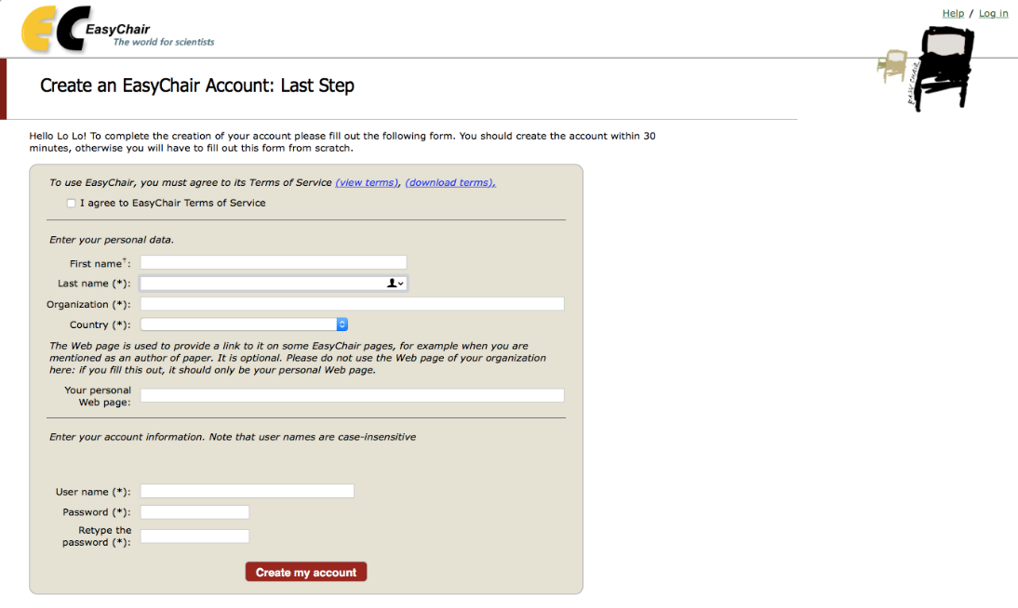
Figure 4: Create an account.

After the account is registered, you may log in to PECERA 2019 simply by clicking on the “click this link” link (as shown in Figure 5), or on the following link PECERA 2019 submission page .
Note: If your username appears taken, it is possible that you have signed up for EasyChair in the past for another conference. In this case, you simply need to ask the system to remind you of your password based on your username.

Figure 5: Link to the log in page.

Submit your abstract(s)
After logging in to the EasyChair website for PECERA 2019, you may click on the “New Submission” link located in the top-left corner of the menu bar to submit a new abstract.
Follow the on-screen instructions and fill out all the required information (as shown in Figure 6) about the authors.
Note: You must use the same email address that you signed up with when creating the EasyChair account.
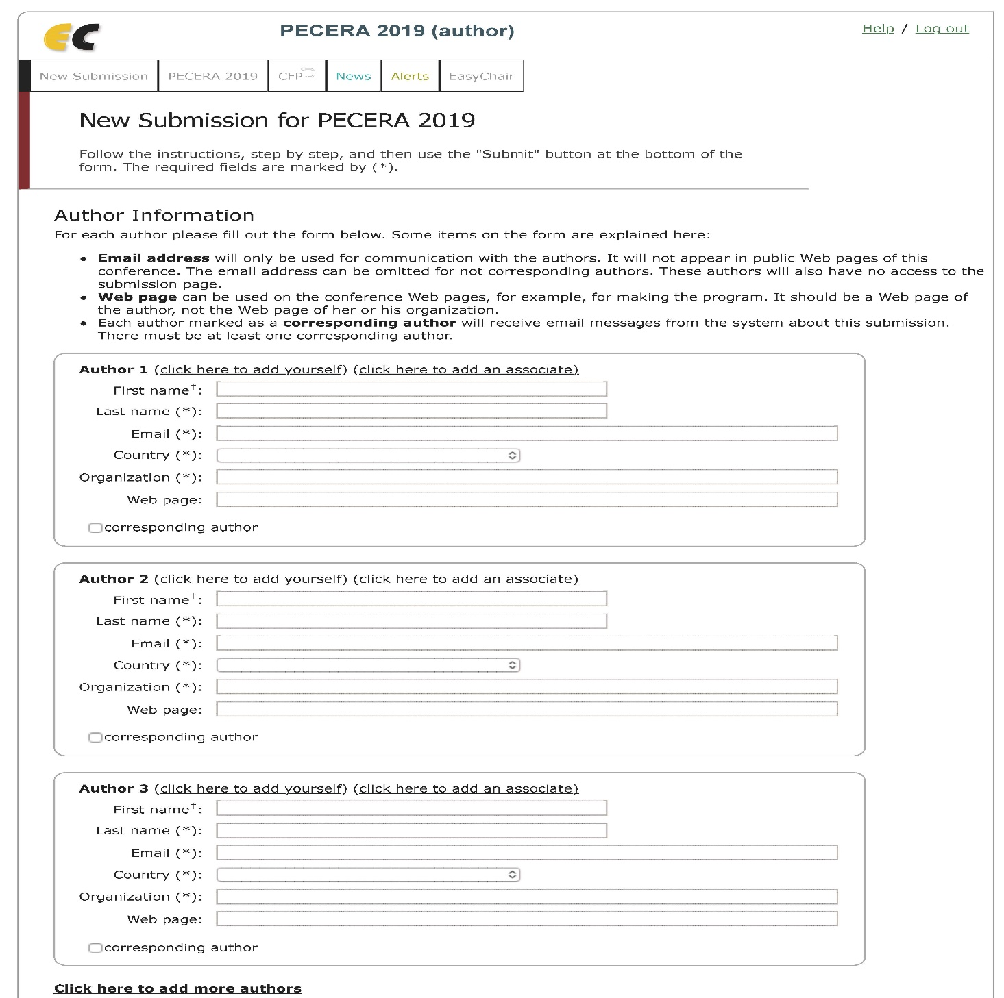Figure 6: Authors information.

Fill out the text abstract, keywords and the related topics (as shown in Figure 7).
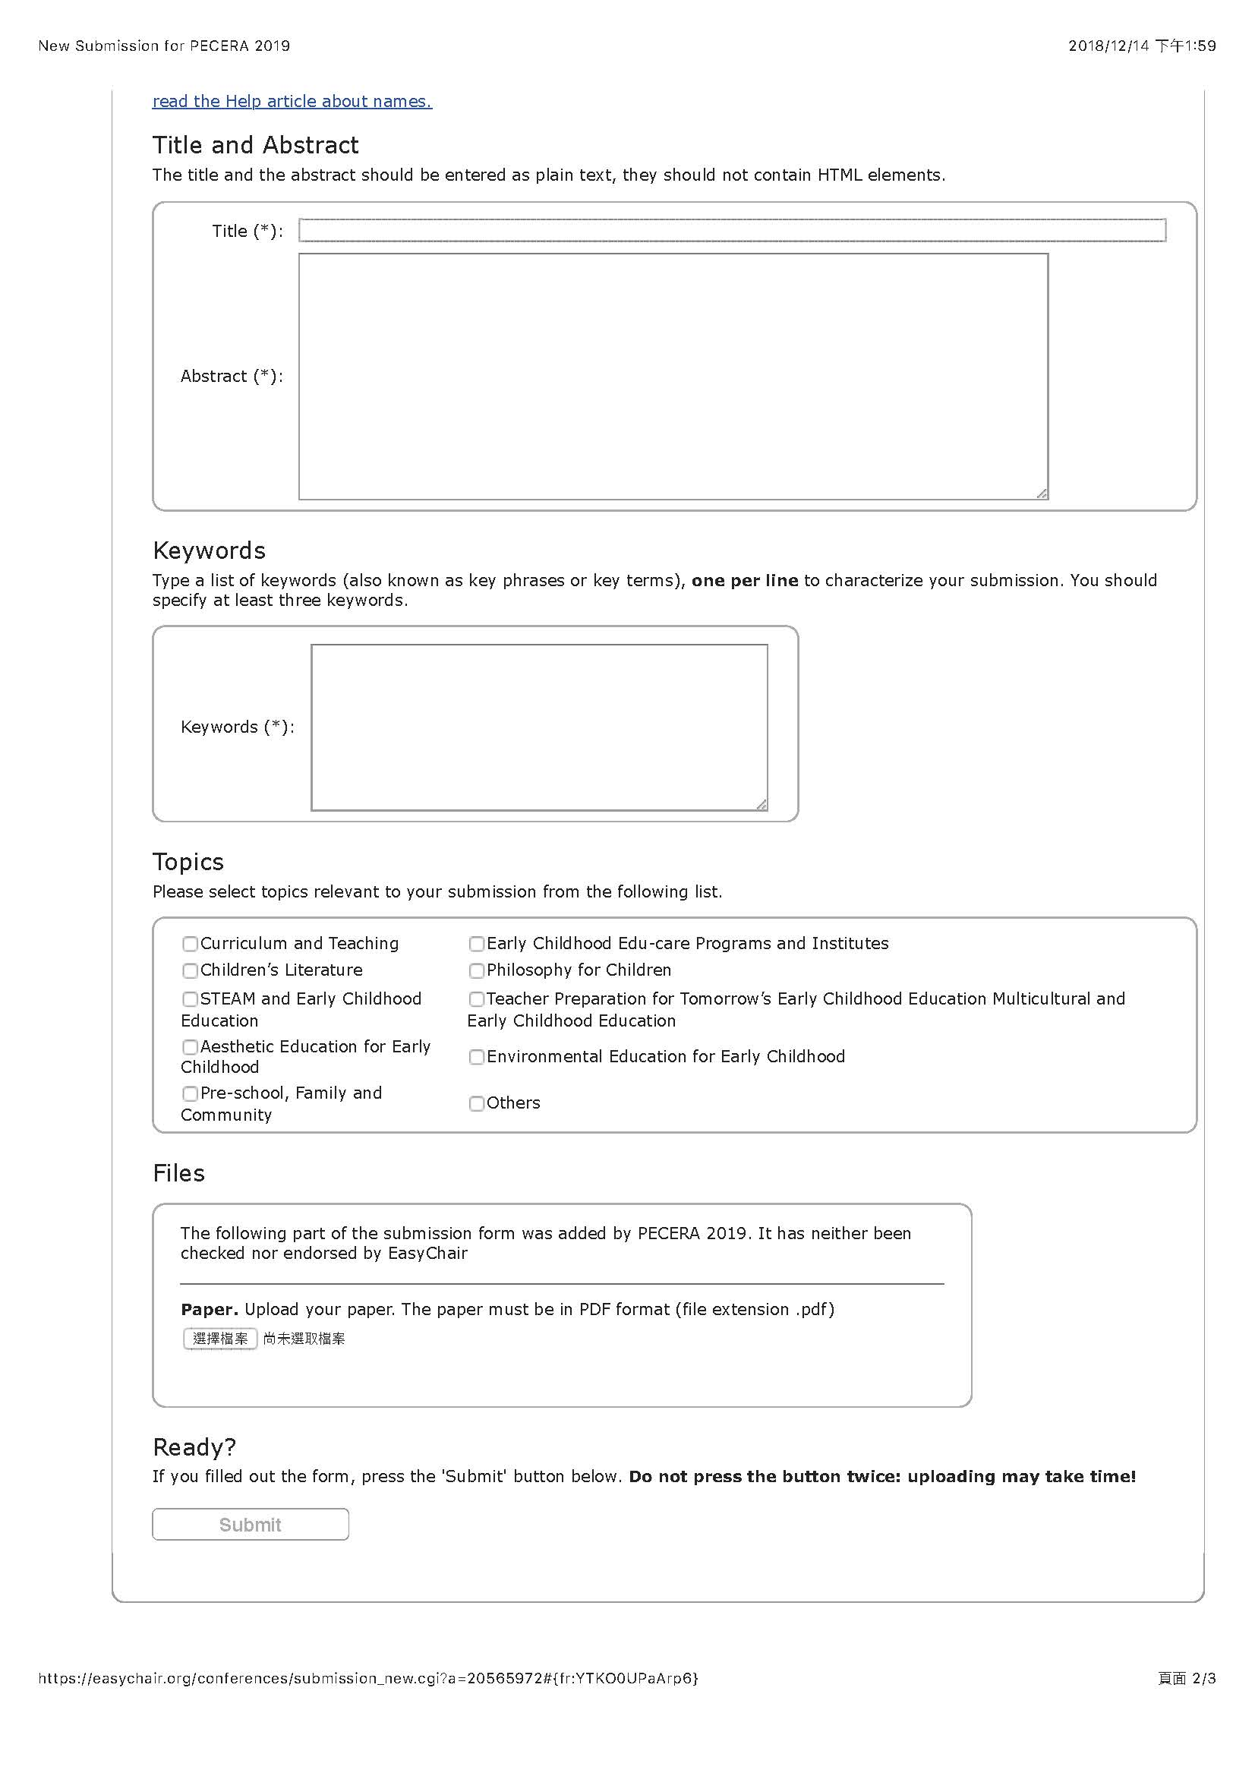Figure 7: Abstract submission.
Choose whether poster or abstract section you prefer to. Then click on the “Submit” link to submit your abstract (as shown in Figure 8).
Please do not submit the full paper or any other files at this stage.
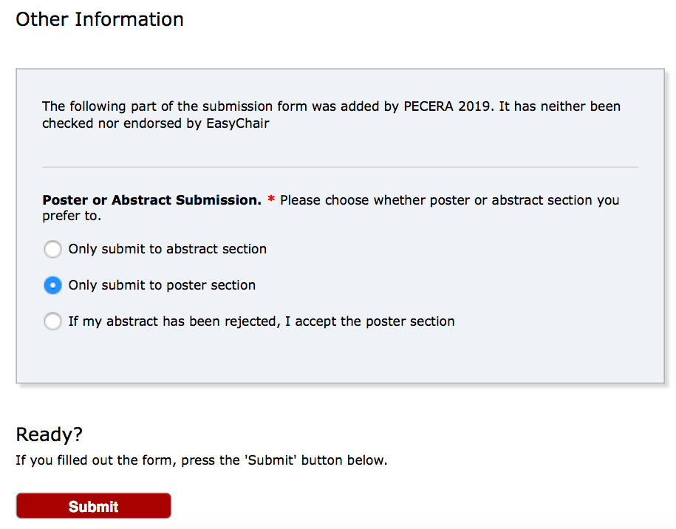
Figure 8: Abstract submission.

After completing a submission, a new menu bar ("Submission #" or "My Submissions" in the case of multiple submissions) is created (as shown in Figure 9). Click on “Submission #” for changing any information about the submission.
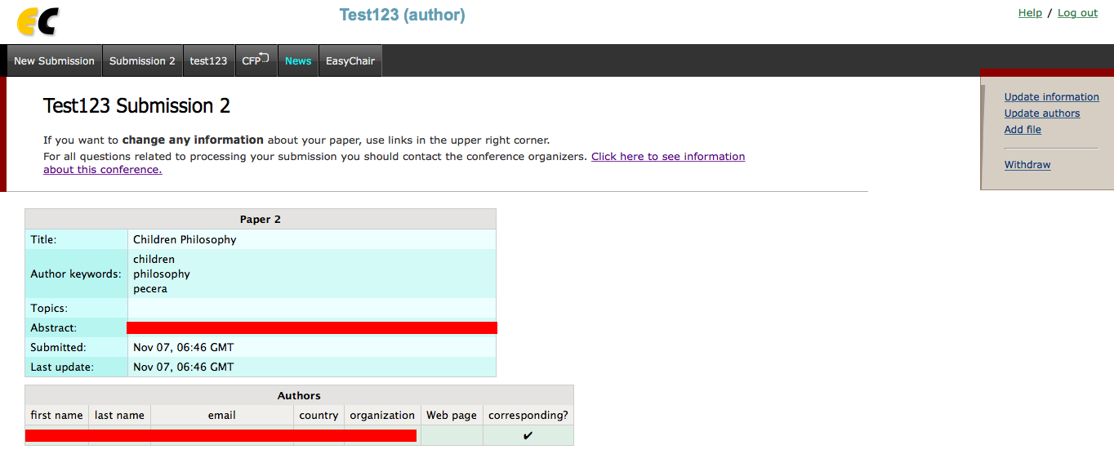Figure 9: A page for changing your submission(s).
Use the links at the top-right corner for:
- Updating information about your submission: select “Update information” from the right-hand menu of the Submission screen to change any of title, abstract and keywords of your submission.
- Updating author information for your submission: select “Update authors” to modify any information about the author(s) and click “save.” In the case of multiple authors, you can add (“Add new author”) or remove authors (Click on “X”); then update the order of the authors by selecting the “Reorder authors” button.
- Uploading files: the “Add file” link may be used to upload files.
Please do not upload any files at this stage.
- Withdrawing the submission: select “Withdraw” to withdraw the submission.
At the end of the submission procedure (a new submission or an update of an old one), you will receive a confirmation email from EasyChair. Once the review process is completed, you will receive acceptance/rejection notification with reviews by email.

